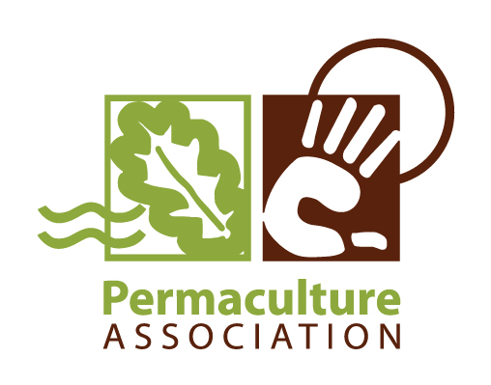
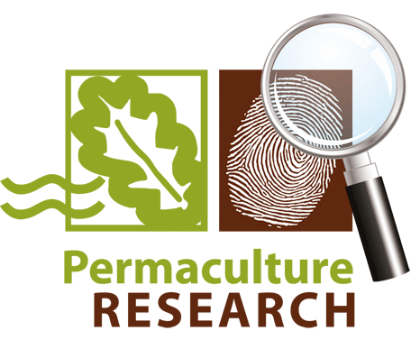
Permaculture Association Member Trial 2014;
Soya Growing in Britain

Chris Warburton Brown, March 2015

Summary
Between May and October 2014 the Permaculture Association ran a trial to establish whether or not it is possible to grow soya on a small scale in Britain. 18 growers planted soy seeds on 22 sites, ranging from the the South Coast to the Scottish Borders.

Every grower planted a minimum of one square metre of seed which the Association supplied. Results were very disappointing, with half of the growers having no germination at all and only one producing anything approaching a reasonable harvest. The likely reason is that the UK climate is not warm enough for soy beans, even in the relatively warm and sunny summer of 2014. We therefore recommend that small growers avoid this difficult crop. Future research could investigate whether growing soy under glass is more successful.

Aims of the Trial
Between May and October 2014 the Permaculture Association ran a trial to establish whether or not it is possible to grow soya in Britain. This trial was suggested by Deano Martin who also wrote the research design.

The stated aim of the trial was to map where people can successfully grow soy beans in the UK.
There were also a number of subsidiary aims:
- To engage members in an Association led Research Project.
- To increase the diversity of crops that members can grow.
- To cultivate an understanding that anybody can do research and make a meaningful contribution.
- To put non GM seed and inoculant into the hands of UK permaculturalists, along with the knowledge of how to grow the crop, and produce the inoculant for themselves.
- To produce simple data of use to members and the food growing public.
- To attract people searching the internet for information on growing soybeans to the Association website.
- To act as a blueprint, or starting point for similar trials in the future.

Sequence of Events
The trial followed a very simple design, asking volunteers to sow a minimum of 1 square metre of soy bean seed in their gardens in early May and then weighing the resulting yield in October.

The actions followed were:
- Publication of Soybean and Inoculant Article by Deano Martin in Permaculture Magazine, with advance notice of the trial, and a link to registration.
- Early April 2014 - Purchased seed.
- Mid-April - Published details of how to register for the trial in the Permaculture Association's e-bulletin.
- Late April - Sent seed to 38 members by post.
- Early May- Members planted seed.
- October- Members harvested soya beans.
- October - Contacted members for results, 18 responded.
- March 2015- Published results.

We sent enough seed for each participant to sow 5 square metres of seed, although we only asked people to sow a minimum of 1 square metre.

Early problems
Two issues threatened the trial before it was begun. The first was our inability to secure any supplies of inoculant. The only soya inoculant available in the UK is supplied in much larger quantities than we wanted. We therefore has to abandon this part of the trial. We got around this by supplying the following advice to the participants:

Soya is a legume, and in its native environment it can fix nitrogen in the soil. However the bacteria it needs to do this are not naturally available in UK soil. In order for nitrogen fixation to occur, the necessary bacteria would need to added to the soil where the soya is growing in the form of liquid inoculant. We have decided not to include this in this trial, largely because it has proved very difficult to acquire small batches of inoculant in the UK. Soya in this trial will therefore not fix nitrogen, and will benefit from any form of nitrogen feeding during its growth. This trial is only interested in whether or not soya will grow (and produce pods), so as long as you have reasonable soil we are not interested in how you feed the plants.

The second issue was the behaviour of the Post Office, which nearly derailed the whole trial. We took the packages of soya seed for weighing by Post Office staff in Leeds and the correct postage was then paid. However many of the receiving post offices disputed the weight of the packages and said too little postage had been paid, so they would not deliver the seed to the trial participants. Participants were able to collect the seed packages directly from their nearest sorting office on payment of a small fine, but several participants in rural areas withdrew from the trial at this point while others had to be sent a second batch of seed, resulting in a delayed planting time.

Numbers and location of participants
38 people put themselves forward to take part in the trial. All of these were sent seed. Of these, we collected results from 18 people growing on 22 sites, which was a reasonable completion rate.

The geographical spread of the participants was excellent:
Brighton, Shropshire, Newcastle upon Tyne, Brecon, Leeds, Pembrokeshire, London, Norfolk (two sites), Suffolk, Leicester, Shrewsbury (2 sites), Cumbria, Essex, Devon (2 sites), Cardigan (3 sites), Dumfries, Lancashire.

Sites used for growing were mostly allotments or domestic gardens, with a couple growing in fields. Space sown ranged from 1 square metre up to 4 square metres, averaging around 2 square metres.

Results
Results were almost universally disappointing. Few people managed to grow any beans at all.

Table 1 What trial participants grew (n=22).
 | Number of sites
No beans germinated | 10
Beans germinated but produced no growth | 4
Less than 50g of beans harvested | 7
More than 50g beans harvested | 1

Here are some typical comments from the ten growers who had no plants grow:
We had zero germination. In adjacent soil to the 2 metres given to the soybean trial we had peas and broad beans germinate and grow.

No results, allotment, beans never germinated, or got eaten by birds or mice.

We followed all the instructions, getting the ground ready etc, and it was a really fun exercise to begin with, but sadly nothing grew at all!

Zero germination, but peas and beans adjacent did well

Four growers managed to get their beans to sprout but got no harvest:

0 beans harvested; Early shoots mostly eaten by slugs as soon as they appeared. About 6 bean plants survived but didn’t grow enough to produce anything to harvest.

Sadly no beans, just green growth

None of the beans I planted outside survived beyond the first little green shoots. We have a slight vole problem here it would appear. I did manage to get a couple of "spare" beans to grow in pots in the polytunnel, so the beans are not to blame.

Seven growers got a handful of beans:
A disaster really I planted some directly into my plot and no plants grew (all other vegetables in the same area did grow). I also planted about 5 seeds in pots of which 2 grew and transplanted and continued to grow hence beans harvested. I also passed on a number of seeds to a friend and they did not grow either.

All beans planted then eaten by rats, one plant grew and is still growing but will be lucky if there is a couple of grammes on it.

I had a series of disasters with cold and wet just as plants came up, then slugs, followed by lack of rain and finally a rabbit. Ended up with 6 plants so a small plot only was needed. Got a handful of beans which I will have another go with next year.

Only 1 germinated. It looked healthy enough but I only got 6 pods each with 1 or 2 beans in it.

10g beans harvested. At first none of the seeds germinated. When it got warmer 5 plants did grow but none more than 15cm tall. They certainly didn't look like they were thriving.

Only one grower had anything approaching a successful harvest. This lady grew her beans in 3x6 foot bed on her allotment in south east London:

Harvested weight 500gr unpodded. I sowed the soy, 3 seeds per pot in toilet paper tubes filled with normal compost in May and planted them out when the shoots appeared. The site was partially shaded but had quite a lot of afternoon sun. The plants grew well but not all the pods swelled up with seeds. I harvested the pods late august 300gr and later in September approx 200gr.

Discussion and Conclusions
The aim of the trial was to map where people can successfully grow soy beans in the UK. The conclusion, at least from this trial, is very clear; almost nowhere! Only one site out of twenty two produced some beans, and even there the yield per square metre was only about 250g. This compares to a suggested yield of 500g per square metre in North American gardens so even this harvest is only a moderate success.

The reasons for the failure are not entirely clear, with many growers blaming their own gardening incompetence for the failure. The almost universal nature of the failure, however, rules out this explanation. Other growers blamed a cold spring, damp, slugs, rats or mice for the failure. There was some evidence that growers in the south were more successful than elsewhere (Table 2) although the sample is much too small to have any statistical significance. In fact Soya UK states on its website growers on light land in the South can grow this late-sown crop (http://www.soya-uk.com/SoyaUKseeds/soya.php), which certainly limits the potential range of the crop.

Table 2. Soy bean harvest by geographical location (n=22)
 | None | Poor | Moderate
South (5) | 1 | 3 | 1
Midlands (6) | 5 | 1
North/Scotland (6) | 4 | 2
Wales (5) | 3 | 2

The fact that the most successful harvest was achieved on what was probably the warmest site in the trials, an allotment in south east London, does suggest that the UK climate is generally too cold for soy to grow well outside. The summer of 2014 was warmer than average (0.5C above average temperatures), and it also had more sunshine than average (113% of average sunshine hours) but this was still not sufficient.(Source:http://www.metoffice.gov.uk/climate/uk/summaries/2014/annual)

Although there is some limited growing of soy in the UK on commercial farms (http://www.soya-uk.com/SoyaUKseeds/soya.php), on the basis of this trial we strongly recommend that gardeners do not waste their time trying to grow soya beans in the open. The lack of suitable inoculant also means that any soya grown on a garden scale in the UK will not have any ability to fix nitrogen. A future trial could usefully investigate if soy beans do better when grown under glass.

On the positive side, a number of the project's subsidiary aims were met. The Permaculture Association engaged 18 of its members in a growing trail on 22 sites across Britain. Apart from the failure of the Post Office, the trial was easy to run and went smoothly. Around 15 hours of staff time were invested in the project, mostly by Tom Kemeny, a volunteer Intern. The total cost of running the trial, including seed, postage and paid staff time was under £120. Participants followed the instructions sent carefully and gave clear and timely feedback on their results. Considering the mess up with the postage, the completion rate (18 out of 38) was pleasing. The Association's research team learnt a lot that will help inform future member trials and we did get an answer to our research question, just not the one we were hoping for!

Finally, on behalf of the Permaculture Association, a big thank you to all those who generously gave their time, energy and growing space to these trials.

