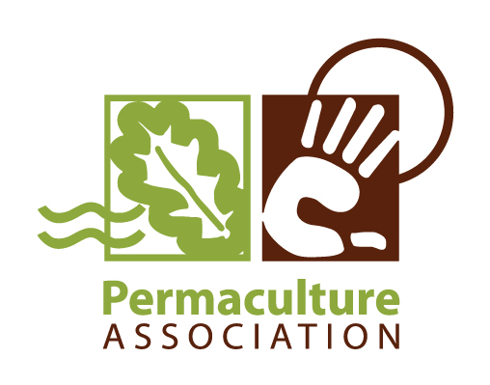
Diploma in Applied Permaculture Design - Tutor Application

If you intend to apply for this training, please notify us asap by emailing Joanna – Diploma Support Worker: diploma@permaculture.org.uk

This is my application to be a Diploma Tutor – registered with the Permaculture Association. I would like to attend the next Tutor Training – Registration Level which will be held on 28 & 29th Nov '12 at Harbourne Hall in Birmingham. The Trainer will be Chris Dixon.

Name:_______________________________________

Address: ___________________________________________

email address: _______________________________

Phone no: ____________________________

PA membership no: ________________

PDC: When, where and who with? _______________________________________

Diploma: Are you accredited under diploma system 4 or system 5? (if unsure leave blank but include date of accreditation) __________

When & where did you accredit?, (if not yet accredited when will your Presentation Event be?)
date: ___________________________ location: ________________________________

Who was your personal tutor, Assessment Tutor and Presiding Diplomate?

- Personal Tutor (or 1st Assessment tutor if different):_________________________

- 2nd Assessment Tutor (system 5 only):___________________________________

- Presiding Diplomate: _____________________________________________

(all the above info is so we can check that our records are correct – thankyou)

Your existing qualifications and experience. (relevant to Diploma Tutoring, You don't need to include your Diploma in Applied Permaculture Design or PDC)
We are keen to know if you have national teaching and assessing qualifications, eg. NVQ D, A or V units, adult learning quals, PTLLS, CTLLS or Qualified Teacher Status (QTS)

Professional and National Qualifications
Qualification | Awarding Body | Date Completed | Duration of course* | Grade/ level.
*(indicate part-time or full time or no. of days/hours.

Other accreditation and courses:
Course or training description | Delivered by? | Duration of the course | Date completed

Relevant Experience: include any relevant work experience (paid or unpaid) and other key learning experiences you consider most relevant to this application:

Job Title or role | Organisation working with or venue or location | Start & finish date | Description

Please comment on how your qualifications & experience have specific relevance to diploma tutoring (approx 150 words – about 2 paragraphs)

Please give a summary list of your areas of Permaculture Design experience (for your online tutor profile):

Please give an overview of your skills, technical expertise and areas of interest (in list form, this is also for your online diploma profile):

Are you interested in gaining accreditation for your tutor training work?
Delete as applicable.

Yes/No

(please note. We are hoping to be able to provide a National Qualification for Teaching in the Lifelong Learning Sector, we are not sure if this will be possible but if we know you are interested we will keep you informed.)

Please include 3 samples of your design work in electronic format – these can be scanned versions of paper-based work if necessary. (this is also for your online Diploma Tutor Profile).

Required Preparatory work,
to be done prior to attending the training.

All successful applicants will be sent a briefing on preparatory work required prior to the training.
This will include a DVD showing recordings of tutorials (may be 'mock-up' examples), and an accompanying observation exercise to be done whilst watching the DVD.
The other bit of the prep work is to then produce a session plan for each of the following events and also bring them to the training.
- An Induction Event
- A Personal Tutorial
- A Design Support Tutorial

After the training and once you are registered you need to be assessed on your delivery of the first one of each of the above tutorial events. You should also consider what other preparatory support you think you require prior to this. We recommend that you shadow a diploma tutor delivering the events you are to be assessed on, or alternatively shadowing of another experienced tutor/mentor, could also be useful.

Please email or post this completed form to Joanna Dornan - Diploma Support Worker:
email: diploma@permaculture.org.uk

or post to Joanna Dornan – Diploma Support Worker, Permaculture Association, Hollybush Conservation Centre, Broad Lane, Kirkstall, Leeds, LS5 3BP


