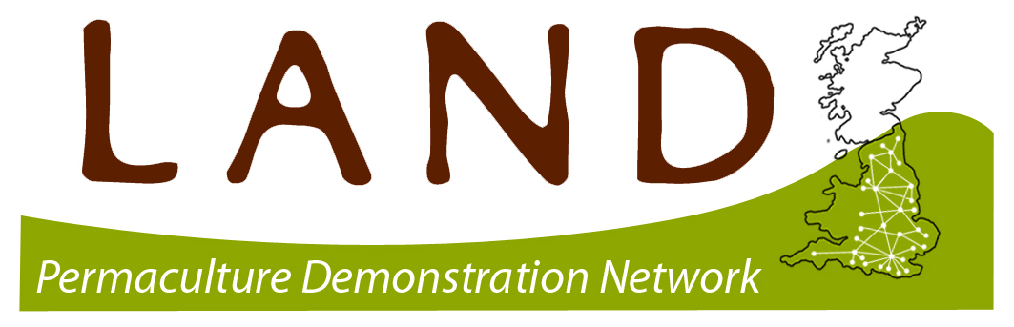
LAND CENTRE APPLICATION FORM

Join the permaculture Learning And Demonstration Network and be part of an exciting and inspiring network of groups and projects all showing that permaculture works!

About You
Your name: …...........
Project name: …...........
Address: …...........
Postcode: …...........
Telephone: …...........
Email address: …...........
Website: …...........
Twitter: …...........
Facebook: …...........
Skype: …...........

Contact details for main contact person (if different)
Address: …...........
Postcode: …...........
Telephone: …...........
Email address: …...........

About your Project
Please tell us a bit about your project. This will be used on your online project profile

Please summarise your project in 20 words:
…...........

Please briefly describe your project:
…...........

What short snappy phrase best describes your project? E.g. “Community Forest Garden”, “Urban Food Project”, “Community Allotment Project”, etc
…...........

When did your project begin?
…...........

How much space do you manage?
…...........

Please indicate which areas apply to your project.
□ Green building methods
□ Retrofitting
□ Water and sewage
□ Natural disaster resistance
□ Owner building Culture and Education
□ Finance and economics
□ Health and Well-being
□ Gardens and orchards
□ Broadscale agriculture
□ Managing animals
□ Forest / woodlands
□ Aquaculture
□ Wildlands and biodiversity
□ Food for free
□ Waste minimisation
□ Land tenure and community governance
□ Tools & Technology
NB this list is from David Holmgren's 'built environment' and 'land & nature stewardship' domains.

LAND Centre Essential Criteria
Briefly describe and explain how the your project design uses uses the ethics, principles and methods of permaculture.
…...........

How committed to your project development are you in the medium and long term?
…...........

What connection with food growing does the project have? NB this only an essential criteria in England until March 2014.
…...........

Which key key project members have a completed the Permaculture Design Course?
…...........

How do you or will you explain to visitors and volunteers how permaculture is put into practice on your site: in person; and through interpretative signage?
…...........

How many visitors could your projects receive at any one time?
…..........

What facilities do you have available for receiving visitors and volunteers?
…........

Are you willing to share skills and relevant information with other permaculture projects, volunteers and visitors via the Permaculture Association website? | yes / no
Are you currently a member of the Permaculture Association and are you willing to maintain membership? | yes / no
Does your project have public liability insurance? | yes / no
Has your project done a risk assessment? | yes / no
Does your project have Health & Safety procedures in place? | yes / no
Will you display membership of (and a weblink for) the LAND project on site and on your project website? | yes / no
Are you willing to receive feedback, including taking part in a biennial check? | yes / no
Can you be available to welcome and receive volunteers and visitors on at least 15 occasions a year? NB You can set minimum numbers and a charge. | yes / no

LAND Centre Desirabe Criteria
These criteria are not mandatory but it would be great if your project was willing to work towards them.
Do you have educational and training resources available for visitors? | yes / no
Are you willing to attend and host regional skill-sharing and training events? | yes / no
Are you willing to contribute to LAND project monitoring and evaluation? | yes / no
Do you run or host courses and events?  If you do, please tell us list them: | yes / no

What research do you do, eg ongoing record keeping of planting and yields; records of inputs and outputs such as those affecting fertility and energy harvesting/usage; systematic photographic recording of the site; other experimental activities?
…...........

PROJECT DECLARATION TO BE SIGNED BY PROJECT LEADERS
This part of the form needs to be signed by the main contact person and another key person involved in your project. Please can you send this part of the form to: The Network Coordinator, BCM Permaculture Association, London, WC1N 3XX and email the rest to network@permaculture.org.uk. We need to receive a paper copy of this part of the form to process your application.

Please make sure that everyone involved in the running and planning of your project has read through the essential and desirable criteria, so everyone in your project will have a shared understanding of what being a LAND Centre means. Please don't hesitate to contact the Network Coordinator on 0845 458 1805 if there is anything that is not clear to you, or you feel needs to be explained in more detail.

We, the project applying to be a LAND centre agree that we:
- Fulfil all the essential criteria and are working towards achieving the desirable criteria.
- Run our project using permaculture ethics and principles.
- Obtain appropriate insurance for the project. The responsibility of insuring our project, remains with us and not the Permaculture Association. You may be asked for a copy of your insurance certificate.
- Will inform the Permaculture Association of any change of address, phone number or email address.
- Include LAND branding and logos on our project website and publicity documents:
- Use our individual project web page to record information about the events that we our holding and the number of visitors/volunteers that have been to our project.
- Will tell the Permaculture Association about case studies and project successes so that the association can include them in the quarterly newsletter.
- Will tell the Permaculture Association if our project runs into difficulties so that they can provide extra support.
- Agree to the information on this application being stored electronically, available to other members of the public via the office, on the Permaculture association’s website and in the Permaculture association’s newsletter ‘Permaculture Works’.

Signed: …...........

Print Name: …...........

Date: …...........

The Permaculture Association will:
- Process your application promptly.
- Visit your project and provide one to one support on site where we will discuss together how to support your project.
- Help identify specific support based on your project's development needs.
- Provide ongoing support via the Permaculture Association's office and put you in touch with other support that we cannot provide.
- Provide information and networking facilities.
- Reserve space in the newsletter to promote your project, find allies and further support.
- Help your project to disseminate research findings, which may include publishing.

