This form is a summary of the forms completed for each Individual Design Assessment carried out for this Interim Portfolio Assessment.

Diploma Apprentice’s name:

Date first registered for Diploma:

Date of this feedback:

Name of Personal Tutor:

Name of Assessment Tutor:

Number of Designs Assessed:

Number of Designs Implemented:

Ratio of Land / Non – Land Based:

Other Information e.g Format:

DIPLOMA in PERMACULTURE DESIGN System 5.2  INTERIM PORTFOLIO ASSESSMENT SUMMARY  Effective from Oct 1st 2013 | 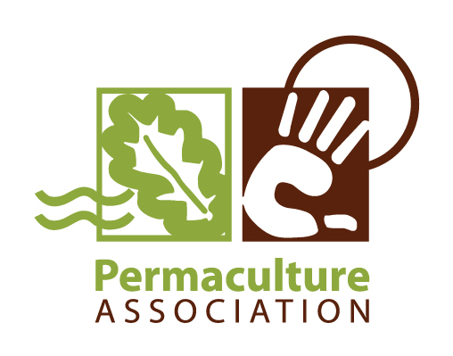

ACCREDITATION CRITERION: 1. Demonstrating design skills
(Section C3 in the Guide to Accreditation Criteria)
 | Feedback from the Tutor | Ready to accredit or more work needed?
There is consistent use of appropriate and intentional design processes, with clear design briefs.
There is consistent use of permaculture ethics, principles and theory, appropriate to the designs presented.
The use of a variety of tools suits the needs of the client and the situation.
There is increasing fluency in the use of design tools and techniques.
The designs are effective, meeting the needs of the clients.
Presentation of design documentation is legible, and suitable for client and others’ understanding.

ACCREDITATION CRITERION: 2a. Applying permaculture in your own life
(Section C3 in the Guide to Accreditation Criteria)
The designs that cover this criterion are:

Own needs have been identified and change is designed to enhance personal and household sustainability.
There is consistency in using design processes and Permaculture theory to develop the solutions.
The implementation of designs has been illustrated and evaluated.

ACCREDITATION CRITERION: 2b. Applying permaculture to your work and projects
(Section C2 in the Guide to Accreditation Criteria)
The designs that cover this criterion are:

To date, an appropriate range of design areas for the apprentice’s situation.
To date, a suitable mix of types of designs e.g. land-based, small scale, conceptual, implemented, etc.
The design solution(s) are relevant and appropriate to the activity and content areas

ACCREDITATION CRITERION: 3. Learning from and developing your permaculture practice
(Section C5 in the Guide to Accreditation Criteria)
The effectiveness of the design work is evaluated using a range of success criteria, including actual and non-material costs.
There is an overall reflection on use of design tools and processes, and use of Permaculture theory and practice.
Overall the designs show an increase in competence in practice, and learning is acknowledged to be progressing.

Conclusions
What has gone well?

What could be done differently, and how?

Comments about portfolio format, general or specific issues.

Designs counting towards the Diploma accreditation without further significant work are:
(a minimum of three)
1. (Title)

2. (Title)

3. (Title)

4. (Title)

5. (Title)
Designs which need some additional work to be ready for accreditation are:
(a maximum of two; detailed feedback is given on the individual design assessment form)
1. (Title)
Brief summary of additional work required before resubmission:

2. (Title)
Brief summary of additional work required before resubmission:

Designs which need major work for accreditation are:
(detailed feedback is given on the individual design assessment form)
1. (Title)
Brief summary of additional work required before resubmission:

2. (Title)
Brief summary of additional work required before resubmission:

Recommended: extra one hour assessment / extra two hour assessment
(delete the one not applicable)

Signature of Diploma Tutor:
Full Name:
Registration status: | Assessment Level / Senior Level (delete as appropriate)
Signed:
Date:

