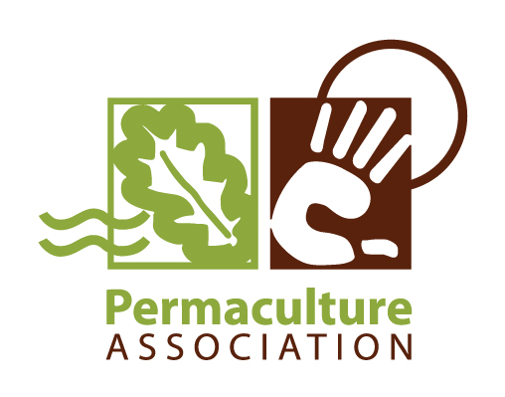
Diploma Tutor Continuous Professional Development
Update Session for Existing Diploma Tutors – re the new Tutor Training Pathway.
- Half Day Session
Date & time: Thursday 29th Nov '12, 12.30pm (for lunch) start at 1.30pm – 5.30pm
Venue: Harbourne Hall, Birmingham (the venue of the Tutor Assessement Training & the National Diploma Gathering)
Cost: £12.50 - to cover expenses for food and venue costs only
How to book: please email: diploma@permaculture.org.uk
How to pay: please send a cheque to the permaculture association office, or contact Helen re bank transfer: finance@permaculture.org.uk
About the session
In light of the new tutor pathway this half day session is to clarify to existing tutors how it applies to you.
We will be:
- overview of where we are at with future development plans and opportunities for diploma tutors within this. includes PA OCN registration.
- clarifying why we need the new tutor training pathway & what it entails
- taking feedback from you on this new system.
- looking at what existing tutors are now required to do in order to retain their tutor registration and negotiating the time-scale for this.
- making and agreeing a plan for you as a group and on an individual basis to take this forward - including recognising prior learning.


