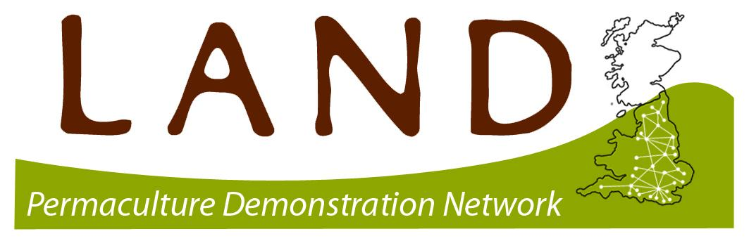
LAND LEARNER
EXPRESSION OF INTEREST FORM

Thank you for your interest in becoming part of our permaculture learning and demonstration network. LAND Centres have the potential to inspire huge personal and societal transformation by simply showing people how permaculture works and how it can be applied in their own lives. Now more than ever, we need these hubs of permaculture excellence to be accessible to every community around the UK. Do you want to be part of this exciting movement?

This form will take approximately 10 minutes to complete. All data is collected in accordance with our privacy policy: https://www.permaculture.org.uk/permaculture-association-privacy-policy

About You
Please tell us how we can contact your project, how we can contact you and your current relationship with us, at the Permaculture Association.

Your Name:
Project Name:
Address:
Postcode:
Tel:

Email: Web:

Facebook URL: Instagram URL:

Please tell us the name that your Permaculture Association membership is under:
Name:

What is your current level of permaculture learning?

Intro Course

Permaculture Design Course

Diploma Student

Completed Diploma

Permaculture Educator

Diploma Tutor

Other

About your Project.

What type of site do you have? (Please write yes next to all that apply).

Domestic garden

Allotment

Community Garden

Smallholding/ small farm

Large farm

Forest Garden

Co-housing/ housing cooperative

Woodland/ Forest

Orchard

School Grounds/ garden

Market garden

City farm

Eco Building/ construction project.

Urban space

Agro/ Ecology/ Horticultural/ Forestry Research Project

Renewable energy/ technology project

Other (Please describe)

Please give a description of your site/ project, including your key aims.

How do you want your site your site/ project to develop over the next five years?

What is your reason for wanting to become a LAND centre?

Thank you!

Please email your completed form to kathryn@permaculture.org.uk

We will be in touch very soon with more information about how to become a LAND Centre and the support available to you.



