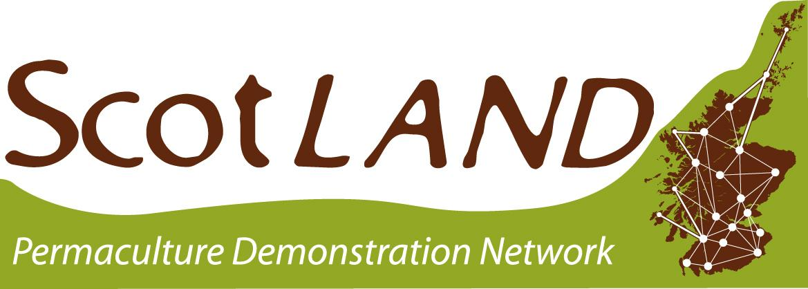

The Learner/Centre Agreement

1. Help With What To Do Next
1. Read - The main contact person and another key person involved in your project need to read this agreement [below] and feel happy to agree to the content.
2. Sign - Download the document and sign it on Page 4 - typing your name is fine, or adding an electronic signature.
3. Send - Save, and email it to scotlandworker@permaculture.org.uk as a file attachment.

If you are unable to send us an electronic document, print and sign a
paper copy and send it to: The Network Coordinator, BCM Permaculture
Association, London, WC1N 3XX

Please do not hesitate to contact the ScotLAND Project Outreach Worker, Finn Weddle, at scotlandworker@permaculture.org.uk if you need further help or would like advice on completing this form.

2. Project Declaration - to be signed by project leaders
a) As the team behind running the ScotLAND Project, we agree that we:
- Will process your application promptly;
- Will organise an accredited tutor to visit your site in order to provide one-to-one support on-site and where we will discuss together how to support your project;* [Your site will be visited when you first apply, and at least once every two years from then on.]
- Will provide ongoing support from our team of tutors in the form of distance tutorials (phone or Skype), which can be arranged for a time that suits you;*
- Will help to identify specific support based on your project's development needs;
- Will give clear and accurate advice on how to work towards the Essential Criteria to become a ScotLAND Centre, or, if already attained, excelling these and the Desirable Criteria;
- Will help your project integrate into ScotLAND Project by holding regular distance meetings (phone or Skype), identifying individual and collective support needs and creating opportunities to share skills and knowledge;
- Will provide you with information on the latest projects, opportunities for further collaboration and networking facilities in the wider permaculture network;
- Will help you make funding applications using Permaculture Association (Britain)’s Charitable Status, if so desired;
- Will promote your courses, volunteer/work opportunities and any other news within the network;
- Will reserve space in the Permaculture Association newsletter to promote your project in order to publicise your activities, and find allies and further support;
- Will support your online presence by listing your project on our website and include it on our interactive map;
- Will provide assistance in adding information to your project page on the Association website if you or your project has limited access to the internet, or if you face other difficulties doing so;
- Will help your project to disseminate research findings and news;
- Where appropriate, the ScotLAND Coordinators, the Scottish Working Group and the staff team at the Permaculture Association (Britain) will help with any related issues and put you in touch with other support that we cannot provide ourselves.

*We will visit as many sites as funds allow; if you are in a position to self-fund visits, even partly, then you will be paying forward the opportunity for another project with less access to funds. We also welcome offers to self-fund distance tutorials.

b) As a project applying to be a ScotLAND Site, we agree that we:
- Will run our project using permaculture ethics and principles;
- Will participate as active members of this network for the next two years at least (unforeseeable circumstances excluded);
- Will work actively towards the Essential Criteria to becoming a ScotLAND Centre, or, if already attained, excelling these and the Desirable Criteria;
- Will remain in regular contact with the ScotLAND Project team;
- Will attend at least one meeting a year of the ScotLAND Network - in person, over the phone or on Skype, or at our annual Permaculture Scotland Gathering;
- Will respect the ScotLAND tutors’ assessment of our project, and advertise accordingly;
- Will include ScotLAND logos on our website and publicity documents;
- Will refer to ScotLAND and Permaculture Scotland in media coverage of our project; [If there is limited space please try to include the Permaculture Association's website details.]
- Will record information about the events that we are holding and the number of visitors/volunteers/course attendees that have been through our project, and send them to the ScotLAND Worker quarterly; [Data can be added directly through a spreadsheet which you will be inducted in.]
- Will acknowledge the Permaculture Association’s Health & Safety Assessment and maintain the site to the highest possible safety standard, especially when accepting visitors;
- Will obtain appropriate insurance for the project, including public liability; [The responsibility of insuring our project remains with us and not the Permaculture Association.]
- Will inform the Permaculture Association of any change of contact details or key personnel;
- Will tell the Permaculture Association about case studies and project successes so that the Association can include them in the quarterly newsletter;
- Will tell ScotLAND if our project is running into difficulties so that they can provide extra support;
- Will agree to the relevant information on our application being stored electronically and being available to other members of the public via ScotLAND, the Permaculture Association’s office, the Permaculture Association’s website and the Permaculture Association’s publication Permaculture Works.

3. Signatories
1) Main Contact Person
Name & signature
Role
Date | DD/MM/YYYY
2) Another Key Member of the project
Name & signature
Role
Date | DD/MM/YYYY

