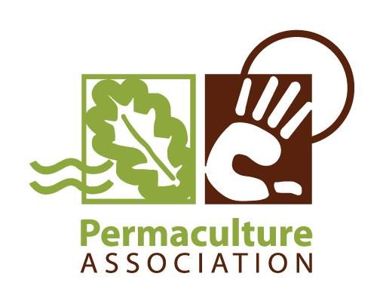
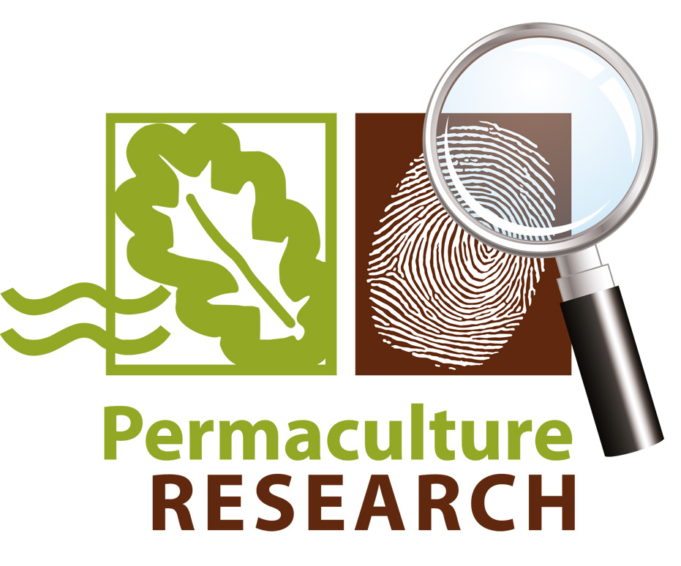

International Permaculture Research Network:

Full Summary

by Cat Richards

Background and Aims of the Project

The Permaculture Association UK is working on building the evidence base for permaculture and improving permaculture practice. The international permaculture research project was set up as a response to the recognition that there is a lot of permaculture research going on around the world but the majority is neither published nor disseminated. In order to support people in sharing their findings, and to further the development of consistent research programs around the world, it was decided to carry out four Surveys looking at different aspects of research to inform the building of a research network.
The first Survey investigated the scope and scale of permaculture research (full report available here) and Survey 2 looked at 'What research is wanted?' (full report available here). The aim of Survey 3 was to identify how respondents collaborate and share information (full report available here) and Survey 4, entitled mapping the routes to discovery, aimed to examine the processes and tools permaculture researchers use to carry out research (full report available here).

Methods

Surveys with open questions and prose answers were used to allow full expression of people's opinions and views whilst avoiding leading questions. Many questions had to be quite loosely worded to try and accommodate as many research approaches as possible. The surveys act like a giant brain-storming session where each person comes up with the answers alone and then they are pooled. The online survey format, in addition to being quick and relatively easy, also removes social factors which can have a negative influence on the productivity of such sessions where the primary goal is to distil into solutions a number of people's experiences of problems. Where appropriate a 'yes/no' question format was used.
The answers were analysed using narrative analysis to identify common themes in responses. This was achieved by inputting all valid responses into a mind map and then grouping them by common themes.
Survey 1

Launched by Anna Schmidt in 2012, Survey 1 attracted the most participants of any of the surveys. A whopping 204 people from 51 countries took part, between them representing 410 organisations, projects and institutions. This was the first hint that permaculture research is a field as wide, diverse and interdisciplinary as any imaginable. The range of research questions supported this view, resisting strenuous attempts to classify them into categories.
What was clearer were the areas where respondents felt that support would significantly help them with their research. The most frequently suggested aspect was access to knowledge exchange and a research peer group, followed by access to research methods training and access to land and skilled permaculture practitioners. Other suggestions were access to published research, a research handbook, qualified staff and more hours in the day.
Perceived barriers to carrying out research included lack of funding, difficulties in collaboration, lack of access to skilled labour, low acceptance of permaculture as a research discipline and lack of knowledge (in order of prevalence).
When asked about barriers to accessing other people's research, researchers found that lack of an efficient information network, lack of awareness of other people's research, lack of time, lack of funding, lack of internet access, large distances and language barriers were the most commonly mentioned issues.
Aside from the requests for more hours in the day (although it would be nice!) it was encouraging to find that most of these concerns could be addressed by a well designed research network.

Survey 2

Survey 2 (entitled 'what research is wanted?') was opened to respondents in June 2012. The survey gauged interest in large-scale research projects and found that an encouraging 81% of respondents are interested in taking part in large-scale research projects.
Questions exploring which areas of research people would like to see investigated by others elicited some really interesting answers in which the theme of building the empirical evidence base for permaculture was very strongly represented. The diversity of the land-based suggestions was matched only by the relative homogeneity of the suggestions for people-based research, suggestions about using permaculture to connect people and improve community and individual well-being were received as often as those concerning the empirical evidence base.
The survey also asked for ideas about who should make decisions within a network and what kind of structures would be most suitable. We found that most participants supported a centralised system with a clear and open feedback system designed to promote inclusivity and input from 'those on the ground'. Taken together, the responses suggested that a transparent and accountable system which takes into account regional variation would help to maximise relevance and usefulness of the network whilst retaining global access to expertise and information.
The theme of contributions a permaculture research network could make to the wider world was also explored, with 89% of respondents agreeing that permaculture research could make a meaningful contribution to the wider research community, in particular with respect to interdisciplinary and multifunctional research. By amalgamating the responses we identified eleven aspects of research that a permaculture network should address (as shown in Illustration 2).
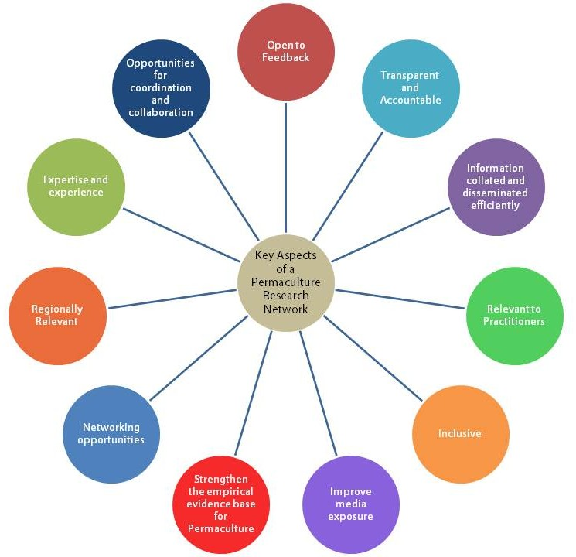Illustration 1: Survey 2 identified eleven key aspects of research that it was felt a permaculture research network should address.

Survey 3
Survey 3 went live in March 2013 and looked at how researchers collaborate and share their research. We found that an encouraging proportion of researchers and practitioners not only collaborate with each other but share their research in some way and 89% were interested in being part of an online research community!
There were a plethora of suggestions as to the optimum format, with opinion fairly evenly divided between them, indicating that perhaps a blend of formats that included email updates, forums, blogs and a wiki would fit the bill.
We found the most common reason for participants not collaborating on research projects was lack of a network of like-minded peers, echoing the findings of survey one, and the most commonly perceived barrier to collaboration was a lack of community. The second most commonly suggested barrier to collaboration was lack of information such as “who is doing what and where” and “research methods and theory”, again echoing the lack of access to a research peer-group lamented in survey 1. Overall, the results suggested twelve features which would promote collaboration and sharing of research both within the permaculture research community and beyond (see Illustration 3).
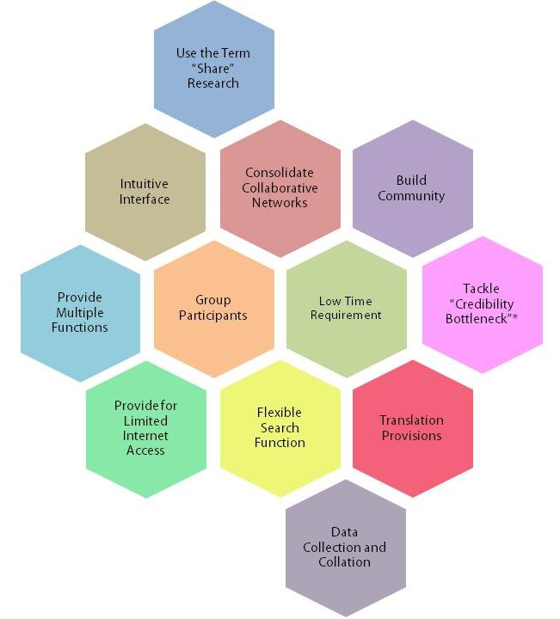Illustration 2: Survey 3 identified features of a permaculture online community that would encourage collaboration and sharing of research.
* Is permaculture “agroforestry, planning or a religion?”
Survey 4

We started collecting responses to survey 4, looking at the methods and resources used by practitioners and researchers, in August 2013 and the findings have been fascinating. The main finding, again, was the amazing diversity of permaculture research. This was reflected in the tools and methods used to carry it out and the practical issues which respondents think permaculture is most applicable to.
We also found that most research is based on practitioners current knowledge needs and is evaluated by observing the practical impact of the project or by sharing and discussing the findings with others. The three most frequently reported resources used to review existing permaculture knowledge were other people, the internet and books.
Soil was the most frequently measured aspect of permaculture projects and the majority of respondents prefer to evaluate and share their research through conversations with friends and colleagues as well as online. From these observations we have proposed some ways in which a permaculture research network could help researchers and practitioners to progress around the research cycle, as summarised in Illustration 4.

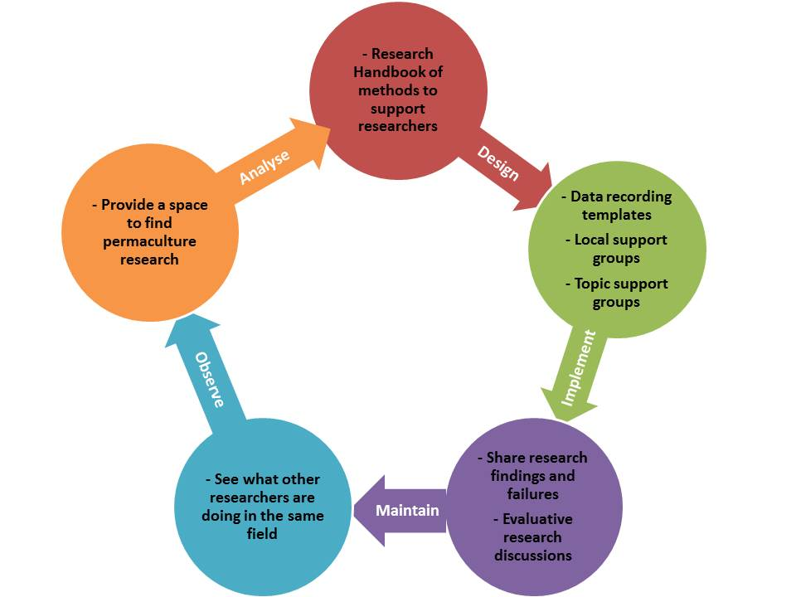Illustration 3: How a permaculture research network could facilitate the research cycle

What Next?

With all the results in, we have started to imagine what an international permaculture research network might look like. We suggest an open source, free to use database of permaculture information and research, co-created by users and easily searchable so that anyone can find the data they are looking for. In addition to that the network should be a collaborative space that provides access to methods training as well as allowing the free exchange of ideas and time through citizen science projects.
We would also like to provide crowd-sourced translation facilities and a live feed of updates so members can keep tabs on areas of interest to them. A self-sustaining network could allow a flowering of experimentation – with easy access to resources on how to run experiments and to experts with decades of experience behind them – anyone could run an exciting experiment and then share their results with the research community.

We would like to build an online Permaculture Research Network which would encourage:

- Cooperation
- Communication
- Coordination
- Face to face interactions
- Sharing of results
- Sharing of methods
- Discussion
- Empowerment
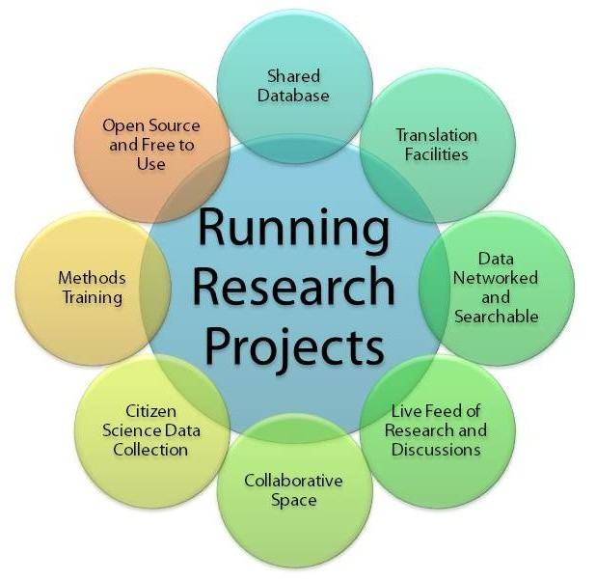Illustration 4: Our vision of an international permaculture research network

http://www.permaculture.org.uk/sites/default/files/association_work/2012/august/report_irs1_pdf_1.2_0.pdf (Full report of Survey 1)

