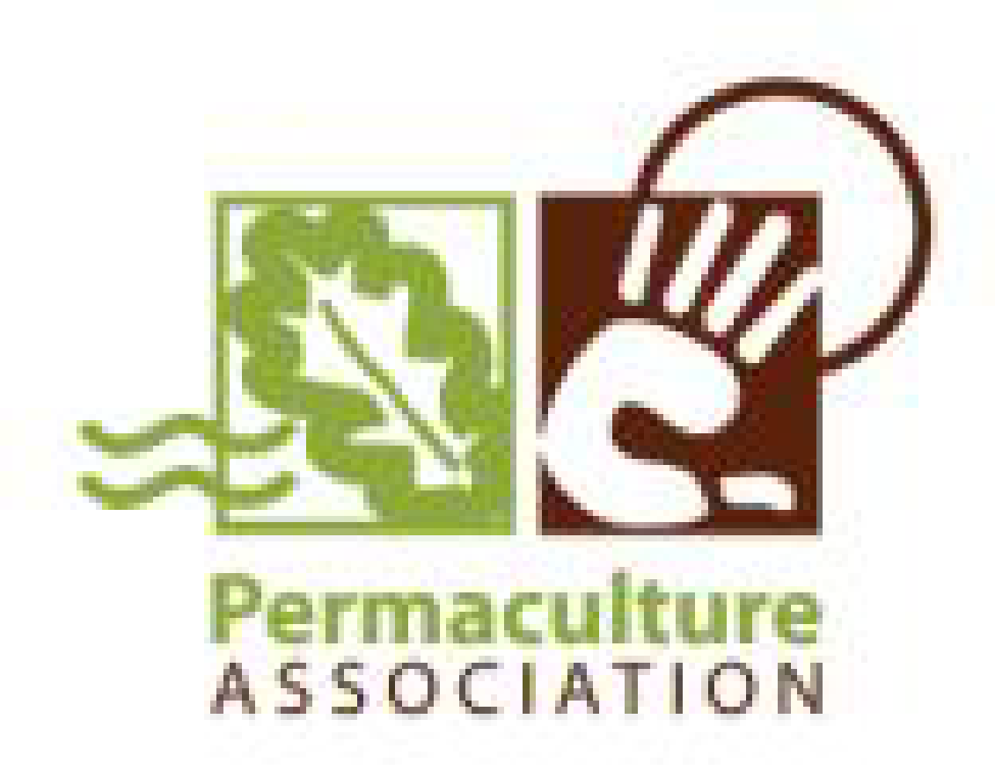
Paramaethu Connect
Open Days Access Fund
Up to £500 supporting permaculture projects in Wales to be accessible to the public.

We’d love to help you open your Permaculture project to the public. Never has there been greater interest and hunger for sustainable solutions, and permaculture is one route that an increasing number of people are exploring in the UK and abroad. This is a great time for us to share what we know and care about, and what we are trying to achieve sustainably!

In Wales, the Paramaethu Cymru network has raised some funds from the Big Lottery and Postcode Local Trust for 2017-18 to support Welsh member projects to share your work with the public locally and online. So if you/your group/your site are a member, or are willing to become a member, you could access some funding support.

- open your doors, gates and online presence to this wave of interest!

Apply for up to £500:
PmC want to help more member projects open their doors next spring and summer, In exchange for some Open Day Access funding we ask you to open your project/organisation/ site for a day, to celebrate and use the work we have done together.
To prepare for your project Open Day we could, for example, help fund:
- necessary insurance, such as public liability;
- improved Health & Safety following a risk assessment [template available];
- improved vehicular or disability access;
- infrastructure for group visits – for example a compost toilet or covered space for talks;
- online access for the public [office based projects];
…Other items that will help open your project to the public? – you tell us!

THere is a total of £6500 available which amounts to 13 or more Open Days Access funding. We hope to attract a spread of projects from all parts of Wales, and will prioritise funding according to greatest need, best offer, as well as according to how many visitable projects are in each area.

If you’re unsure whether you need any of the above feel free to contact Cara Wilson, Wales Coordinator wales@permaculture.org.uk for advice.
Feel free to stretch the boxes and take more space than they currently allow.

Deadlines:
As soon as possible - please email us your completed application. We will assess applications on a first come first served basis as well as trying to make sure there is a good spread across
Wales, so we may hold some applications back until we are sure that all regions are covered as far as possible. we will keep you informed of this.
15th May - all funds must be allocated, spent and invoiced;
1st July - all open days must be completed with photos and attendance sheets returned

APPLICATION FORM
- ABOUT YOU:
Funds are available for organisations or individuals who are members of the Permaculture Association (Britain) or via membership of their regional Paramaethu member group.
Permaculture Association Membership number:
Name of project/organisation:
Address:
Phone Number:
Email:
Website:
Charity/company number [if you have one]:

What does your project/organisation/ site do?
How does your project/organisation/ site reflect , make use of or aim to develop the use of Permaculture principles?
What do you need to make your site/project more accessible to the public?
Be as specific as possible to your individual location – how it can be more visitable/accessible.

2. ACCESS FUND BUDGET:
What would you spend the funding on and why?
itemise all expenditure accurately. Be clear if it is an actual price or a quote. PmC is happy to contribute towards a larger cost if needed, up to the value of £500 maximum, depending on how many projects are approved in each region.

When would the item be purchased/work completed?
All expenditure must be completed by May 2018

3. AN OPEN DAY TO CELEBRATE
In exchange for the Open Day Access funding we ask you to open your project/organisation/ site for a day, to celebrate and use the work we have done together. Your PmC regional group will support you on a practical level as much as they can. PmC and the Permaculture Association will support you with publicity and contacts.
Tell us about your open day event - Tell us the potential date. Don’t forget refreshments, covered space, speakers or skill share. It doesn’t have to be grand, share the skills you have between you and those of your regional group. You could also offer a plant/seed swap, stalls, items for sale, a free shop. SEE OUR OPEN DAYS LEAFLET FOR IDEAS AND ADVICE
We have a training budget too - if you have an interesting speaker trainer in mind we could pay them to give a talk at your event. please contact Cara Wilson to find out more.
It should be accessible (disabled access) and affordable. Choose a time the majority of your audience can make and check there are no clashes with other local events.

How can we help?
How will you get people there? What’s the hook?You need something that will make people want to come - what can they learn/take away from it. Think about forms of publicity - social media, posters, word of mouth, listings, newspaper articles etc. can all help to raise awareness. We can offer you support with online and email publicity. SEE OUR OPEN DAYS LEAFLET FOR IDEAS AND ADVICE.

4. REPORTING:
In reporting to our funders we need to provide evidence of events. We will ask you to provide photographs [please check permissions if they show individuals], and an attendence sheet [we will provide a template], which you can also use for people to be contacted afterwards if they wish.
We would also ask you to write a short article either about your project or the open day event, which we may publish on our website and on Permaculture Association ebulletins [300+ word and photos]. This should act as helpful publicity for your project.
Please indicate below that you will be happy to write a report and a short article

follow up activity
How often do you plan to open again? Do you plan to involve regular volunteers in your project? How do you hope to be involved in your regional group?

5. AGREEMENT
I agree to use the Permaculture Association’s Standards and Guidelines for Events (see attached)
Signature:
Date:
Your name (block capitals):

With Thanks to our funders:
